Background and Objectives
Operational efficiency of business is vital for the success of an enterprise. In today’s competitive environment organizations are required to reduce their overheads while not comprising with the quality of services offered to the customer. Office automation or paperless offices are the buzzwords in business establishments. Computers now are taking over the manual systems which involved more human interaction. Online Examination System coupled with support applications deployed on the system used for organization to make the task of providing quick and better quality services to everyone. The present scope of the application is limited to online testing only. However, the design should be scalable to integrate online course module at a later stage seamlessly

Objective of the Project.

- To design an application for companies using manual testing process in recruiting people.
- Application when deployed will provide the following type of services to the company:
  - Candidate enrollment in the company.
  - Provides interface to candidate to select test category for examination.
  - Test taking and Test Evaluation.
  - Test, Question, Course creation facility.
  - Editing existing Test/Question/Category.
  - Maintaining a log for tracking error and debugging.
  - Generation of result w.r.t test given by candidates.
  - Creating new User/Admin profile.
  - Modifying profiles.
  - Application also encrypts data before writing them into DB.

Why online Examination? What are the advantages of using Online Examination System?

The Online Examination System should be used in an organization because it saves the time of both company and the candidate. As well as it gives the result in seconds.

Advantages of Online examination:-

- It saves the time of both company and the candidate.
- The database is robust, and is in normalized form.
- Using Servlet and JSP it provides quick access to the data base.
- This system uses client side validation which makes the System more efficient.
- The system is platform independent, so while implementing it one should not worry about its working performance.
- System also provides searching (for admin use only), which helps admin to search the particular data in the database he need not to type a query in the database (it was the main drawback of the existing system).
- All the candidates appearing in the examination will receive different questions on their desktop (this facility is also not available in the existing system).
- Questions in this system are of many types (multiple answer, single answer, true and false), by means of which admin can choose the type while preparing the test for candidate.
- Questions can be random or sequential by which admin can decide that whether the questions are randomly displayed on the candidate’s desktop or sequentially displayed.
- Questions are stored in the database that means the page on which questions are displayed is not static HTML pages.
- Unlike the existing system it is not resource hungry, because it does not launch new interpreter on every request.
- The connectivity with the database is more efficient because it uses the connection pool, which formulates a new connection when the system is started for the first time and uses the same connection until the system is clogged (stopped).
- System proves it’s robustness by many means like if the user will logout in middle of the test then the test will be submitted to the database automatically and he will not be able to make any type of changes in that particular test.

Scope

Online Examination System using J2EE technology for recruiting purpose works towards the removal of manual paper work and labors involvement to some extent in maintaining various ledger regarding Candidates information, test data, user enrollment, the validity of user, etc.
The proposed system is a Browser-Based System for organization-wide use of implementing Online Examination System. The scope of existing system is very limited as this function is managed using Common Gateway Interface and requires more human involvement.
Online Examination System meets the following requirements.

Proposed system

- Existing system is intranet based system on Windows.
- The response time of the proposed system will me much better than the existing System because this system will be in Servlet and jsp, which does not create the new process in every request.
- The system will not have validation problem, before entering data into the database it will check all the fields properly.
- The proposed system will be platform independent.
- The data will be stored in the database in B.C.N.F. form.
- All the data will be stored in a central database.
- Advanced searches will be provided.
- All the users will see different question on the desktop.
- System will not be resource hungry, because it does not require to start a new interpreter.

Online Examination System will be divided into two parts, which will perform predefined functions according to their roles and responsibilities.

1) Administrator.
2) Candidate

Functions performed by each category of users of the application are as follows.

- Administrator

  - Creation of Courses.
  - Creation of Questions in existing categories.
c) Creation of Test patterns in existing categories.
d) Editing/Deleting existing categories.
e) Editing/Deleting existing Questions.
f) Deleting/Editing existing Tests.
g) Search for existing Test/Questions/Admin/Users.
h) Add/Remove User Profile.
I) Add/Remove Admin Profile.
J) View Log for Error Tacking and debugging.
k) View Result of the tests.

2) Candidate

a) Create a new profile.
b) Edit their Existing Profile
c) Can select between the existing available courses to give exam(if already not given).
d) Can appear for the examinations and interact with the interface as decided by Test Taker (Admin).
e) Can Submit the form any time in between the time period of the test.

Assumptions

- Super administrator will have access to the entire system.
- Only administrator can manage creation test patterns/ categories/ questions or new admin profile.
- Only Administrator can remove user from the system.
- Users have just limited access to the application which is decided by administrator.
- At any time user can submit the test.
- Admin can log out from the application any time s/he wants to.
Operating Environment - Hardware and Software

Platform:
- Windows Platform
Tools:
- J Creator pro 3.10
- Microsoft Office XP
- Rational Rose
- Microsoft Visual Interdev 6.0
- Smart draw

4.1. Hardware requirements

- Reltex LAN Card or other
- IBM PC
- Printer

4.2. Software requirements

- Windows 9x/2K/XP
- Oracle 8i Personal/Enterprise Edition
- Apache tomcat 4.0.1
- J2sdk1.4.1
- Rational Rose
- Smart Draw

Forms and report Specification

Welcome Form

This form is displayed in the starting of the system. Welcome form displays two options:-
    - Admin
    - User
And asks the user to select one of these. Then click the submit button.

Admin Login page:-

If user selected the admin option then this is the next page to be displayed. In this page the admin is asked to enter the login name and password then this page matches the data entered by the admin into the database and if the data is matched then the next page (admin home page) is displayed.

Admin Home Page:-

This is the main page in which admin is going to do the changes. The option displayed in this forms are:-
            - User Updation
            - Test Option
            - Admin Option
            - View Result
            - View Log
Admin has to select one of these options and click submit.

User Updation:-

This form shows two options:-
            - Create new user (admin can create a new user).
            - A combo box which display the existing users (admin can delete, modify the existing user)

Test Options:-

Test option page displays three options:-
            - Test (This option is used to edit ,delete or create test)
            - Question (This option is for edit ,delete and create questions)
            - Category (This option is for edit, delete or create category )

The test option and the Questions both show the existing category, this is for the ease of the admin so that he/she can add the test or question in the particular category. In these two pages when the admin will click on the combo box which is displaying the category the existing test/questions will be displayed by which admin can see that what test/questions are already created so admin can modify the existing one if he wants to
Admin Options:-

In this page admin can create a new admin and if admin wants then he/she can delete or modify the existing admin login.

View Result:-

As it is told earlier that the result of the user (who is giving the examination) will be not displayed to him. This is the admin who will see the result and decide that whom to select and whom to not . So this is page in which admin can see the result of all the candidates who had appeared in the exam.

View Log:-

As we know that the whole sole of this system is admin, he/she can do what ever he wants to. So the system has the facility to track admin. This is why this page is there. This page shows all the activities performed by the admin.

User Login Page:-

This is the user login page in which user has to enter the name and the password which is matched in the database. This page also shows the hyperlink named ‘click’; this is for the user who is not registered already.

User Registration Page:-

If user clicks for the new registration in the previous page then this page is displayed.

Select Category Page:-

This page allows the user to select one of the categories to start with the exam although user has to give the entire category displayed but he can choose which to give first.

Test Description Page: - This page gives the brief knowledge about the test.(Like passing score, total no of question, time bound, etc.)

Warning Page:- This page tells the users do’s and don’ts while appearing for the examination.

Start Test Page:- This starts the test.

Result Page:- This page gives the list view of the questions attempted by the particular user and also gives the vote of thanks to them.
Introduction

The Online Examination System is an Intranet Based system running on Internet Explorer browser. The System is designed against the manual recruiting processes used by some companies which involve lots of paper handling and manual entries done. Such systems are very prone to errors. Whereas my Online Examination System is a fully automated system which requires very little human involvement and is user friendly and practically require no training as such they were trained on other details. The application handles and manages all the detailed records of both Test Taker and the candidates appearing for the exam. My System also enables the admin to view the result of the performed tests which can be sorted out according to the fields (such as marks, category, Users etc.) desired by the test taker. The test has purely objective types of questions such as Multiple Choice, Multiple Answer or True and false.
The operation of my system is divided basically into two parts i.e.-Administration & Users part. In the administrator part the admin creates new questions for the test to happen under some category (course). He then defines a Test pattern for the test (which may include total no of questions, min. passing score, Time for test, Back scrolling etc.) which users appears. In the Users part users has very limited access and remains and interact with the system as set by the admin.
For a new user to the system who is willing to give test has to first register with the system then the system displays the name of the courses he/she has to appear. If he has already appeared for the test then that category is disabled. Users then selects the test to give, a test description with the warning appears before starting the test. On completion of the test users is given a vote of thanks and his test data are saved into the database. Results are generated with this saved data.
Various activities are performed during the working of project. These works can be classified under two category-admin activity & users’ activity.

Admin Activity includes things like:
- Creation of admin account which can happen offline too.
- Add new course to the application.
- Create new questions under earlier created course.
- Set new test pattern for the test.
- Publish test.
- Edit or delete existing test/Questions/Course.
- Result view and list users according to that.
- View log for error tracking.

User activity includes things like:
- User registration (is mandatory before the commencement of the test).
- User logging into the system.
- Selection of course by user.
- Appear for the test.

Requirement Design

Requirement analysis
A complete understanding of software requirement is essential to the success of a software system. Requirement analysis is a software engineering task that bridges the gap between system level software allocation and design. It may appear to be relatively simple task, but communication content required is very high. It enables the system engineer to specify software function and performance indicate software’s interface with the other system elements.
Requirement analysis may be divided into five area of effort. They are:

- Problem Recognition:
Communication for analysis must be established so that problem recognition is ensured. The goal of the analyst is recognition of the basic problem that some of the searching systems are not reliable and there was a lack of data integrity. Hence database had to be designed with more reliability.

- Evaluation and synthesis:
It is next major area of effort for analysis. We had to define all the observable data objects, evaluate the flow and the content of the information. We elaborated all the methods to be used in the search engine system and tried to grasp events, which affect the system. Data flow diagrams were used to identify the flow of information.

- Modeling:
Models are used to gain a better understanding of the actual entity to be built. The models focus on what system and not on how it does it. Generally the basis models used are functional and behavioral.
The functional model focuses on the input, process and output produced.
The behavioral model focuses on the events from the outside world. It helps the analyst to observe the state of the system at a particular moment.

- Specification:
Specification may be viewed as representation process. It should be relevant to the problem.

- Review:
Review has to be taken to check if the system is going in the right way. One way is to test the modules of the system and the compare the output with the desired output. This helps in getting the real picture of the project.
Data Flow Diagram

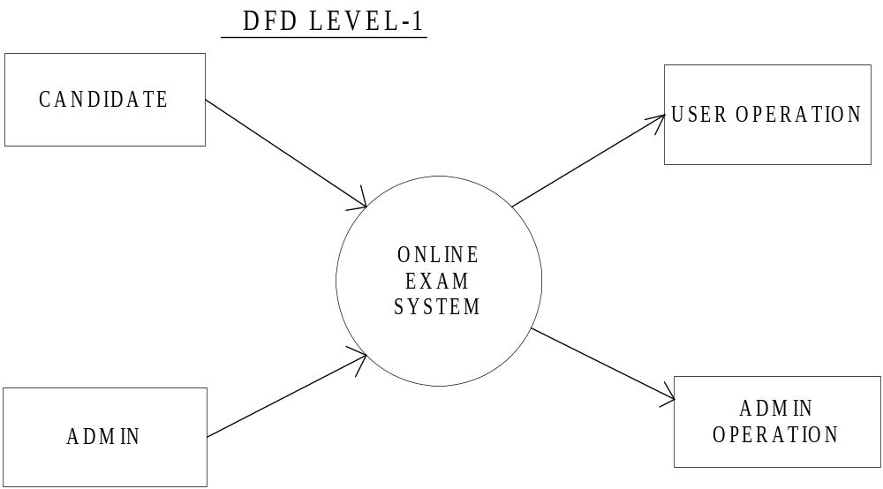
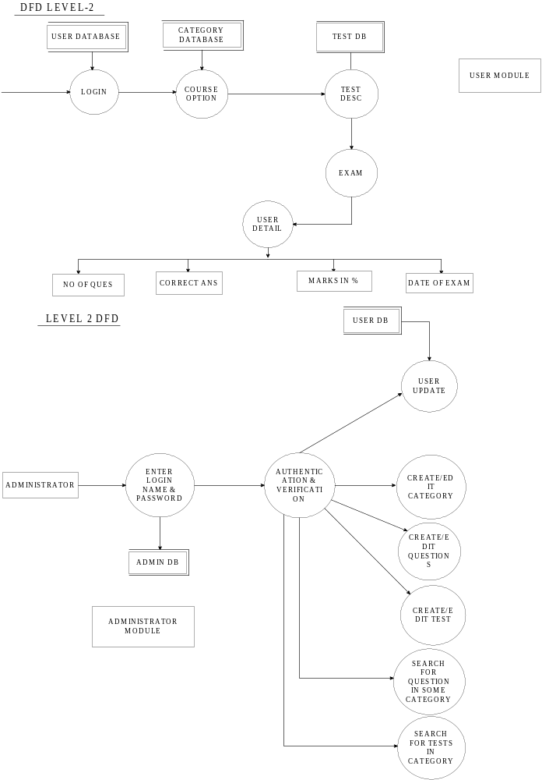

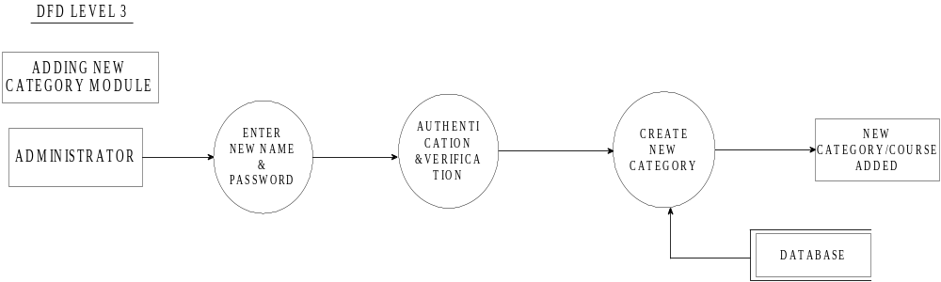

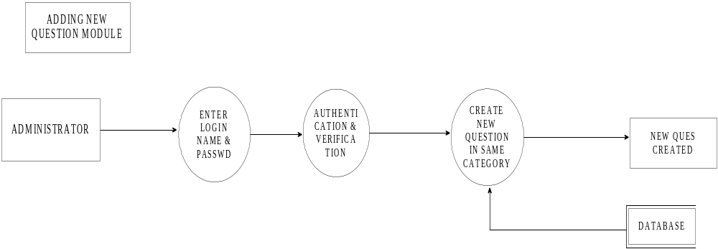

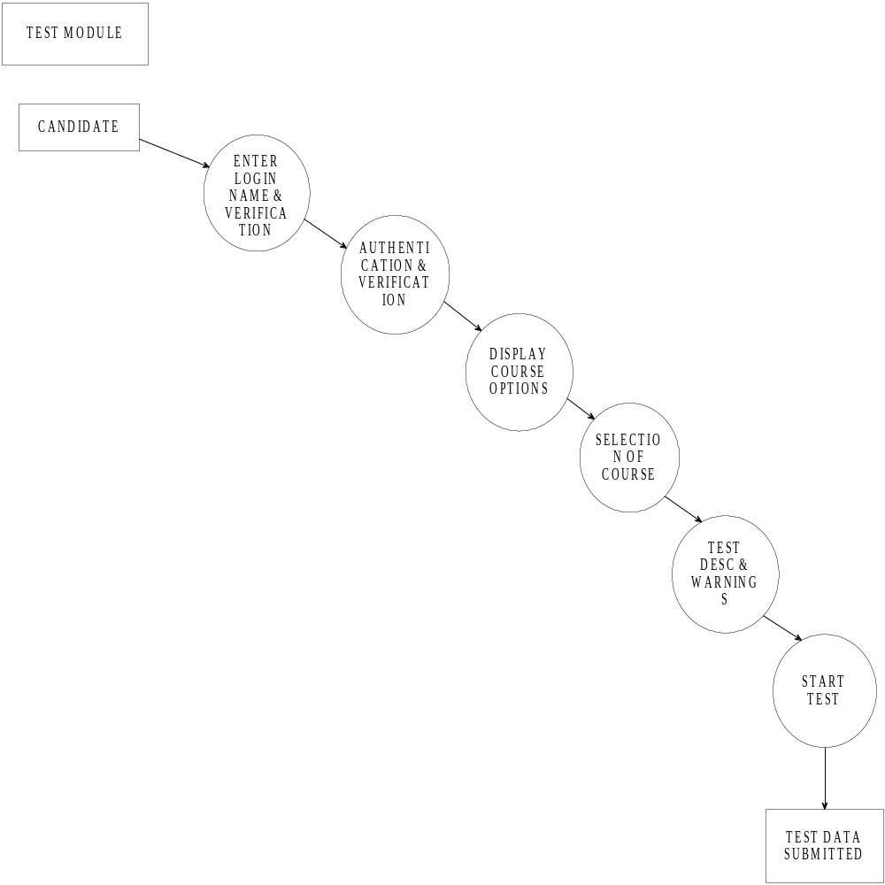

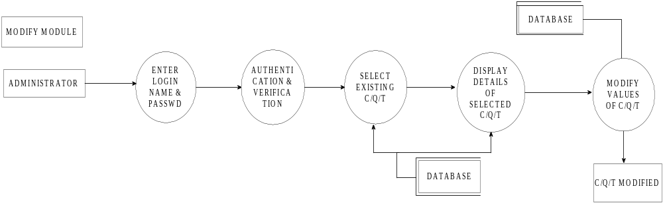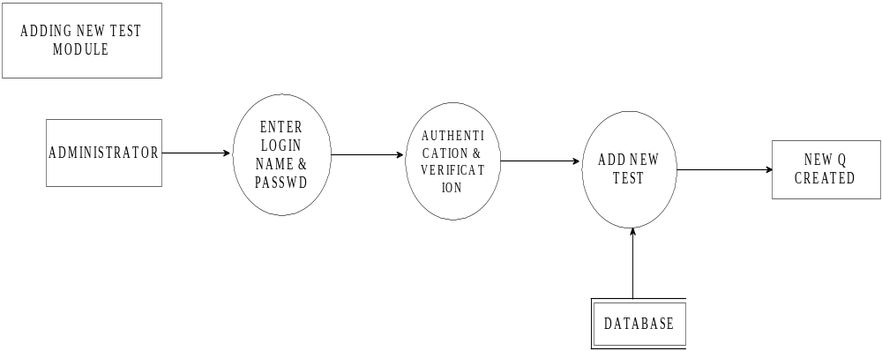
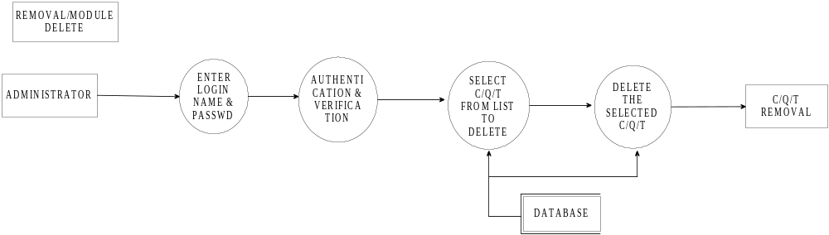
ER-Diagram

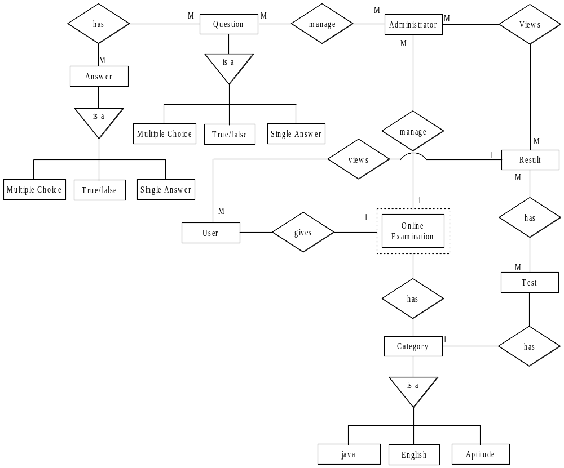
Project Planning

August ’04 – September ’04:
Detail study of online Examination.

September ’04 - October ’04:
Survey regarding requirements and needs for companies
Conducting manual examinations

December 20th – December 31st ’04:
Requirements Analysis of online examination system and other things to be used.

January ’05:
- Project Planning
- System Designing.
- Database Designing

February ’05 – March ’05:
- User Interface Design.(In Html) and development of Protocol
- Coding.

March ‘’05 – April ‘’05:
- Integration and
- Maintenance.

April ‘’05 – May ‘’05:
- Testing and
- Debugging.

PERT CHART

PROJECT EVENTS:

    - Selecting the project
    - Setting the objective
    - Feasibility study of project scope
    - Platform and tools
    - Requirement analysis
    - Review of requirement analysis
    - Design approach / Exploring Alternatives
    - Diagrammatic representation
    - Designing modules
    - Implementation
    - Testing
    - Sample results and analysis
    - Final Project
    - Project Report creation
    - Final project Implementation

Project Design Part II
Table design

- Table Structure
(The names in bold characters have reference to some other tables).

Table Name | Description
Users | This table stores the data about the users who are members of the institute.
Admin | This table contains the data of the authority members of the firm.
Category | This table contains the name of the category i.e. topic name. Questions are made under category table.
Questions | Has reference to Category table. This table contains all Questions that will be used in test. Admin selects new questions from this table or add question to this table
MC_Answers | Has reference to Questions table. This table contains the Correct plus the option answer for Multiple Choice type Questions.
TF_Answers | Has reference to Questions table. This table contains the Correct plus the option answer for True/False type Questions
MA_Answers | Has reference to Questions table. This table contains the Correct plus the option answer for Multiple Answer type Questions
TestData | Has reference to Users table This table stores information about the users who have given the exams. Result sheet is generated using this table.
Test Category | Table is contains information about publish or unpublished tests.
Test_Questions | This table tracks answers given by users in a particular test and helps in  Generation of results.
Test | Table contains the information about the test patterns.
Selected | Table contains information about the students who have been selected.

Data Dictionary

Users:–Table of Users (Candidate) who can appear for the exams.

Field | Data Type | Size | Null | Index key | Default | Constraints/Rules | Remarks
User_Id | number | 5 | No | P.K. |  |  | Primary key for the each user.
Fname | varchar | 50 | No |  |  |  | First Name of the User
Mname | varchar | 50 | No |  |  |  | Middle Name of the User
LName | varchar | 50 | No |  |  |  | Last name of the user
Password | varchar | 25 | No |  |  |  | Password of the user.
Gender | varchar | 1 | No |  |  | M,F | Gender of the user.
Address | varchar | 150 | No |  |  |  | Full Postal address of the user.
Telephone | Number | 15 | No |  |  |  | Contact no of user.
Email | varchar | 75 | No |  |  |  | Email of the user.
Date_of-Birth | Date |  |  |  |  |  | Date of birth of the user.
Qualification | varchar | 25 | No |  |  |  | Password of the user.
Attempted | number | 1 | No |  | 0 | 0,1 | Check whether user has given paper or not.

Admin: Table of Admin who is authorized to create the Test.
Field | Datatype | Size | Null | Index/key | Constraints/Rules | Remarks
admin_id | Number | 5 | No | P.K. |  | Unique id used for identification
Login | Varchar | 25 | No |  |  | Used for login name of admin
Password | Varchar | 15 | No |  |  | Password of  Admin
FName | Varchar | 25 | No |  |  | First name of admin
LName | Varchar | 25 | No |  |  | Last name of admin
Email | Varchar | 50 | No |  |  | Email id of admin
Contact_No | Number | 15 | No |  |  | Phone no of  Users.
Designation | Varchar | 50 | No |  |  | Post of admin

Category –Table of topics for encompassing questions in it.

Field | Data Type | Size | Null | Index key | Constraints/Rules | Remarks
Category_Id | Number | 5 | No | P.K. |  | Primary key for the Unique IDs.
Name | Varchar | 50 | No |  |  | Name of the Category.
Description | Varchar | 75 | No |  |  | Detail description of the category.

Questions- Table of Questions of all types.

Field | Data Type | Size | Null | Index key | Constraints/Rules | Remarks
Ques_ID | number | 5 | No | P.K. |  | Primary key for unique question.
Question | varchar | 150 | No |  |  | Question related to some Category.
Category_ID | number | 5 | No | F.K. |  | Foreign key reference from category table
Type | varchar | 2 | No |  | MC,MA,TF | Type includes MC,TF&MA

MC_Answers- Table contains Answers of Multiple choice questions.
Field | Data Type | Size | Null | Index key | Constraints/Rules | Remarks
MC_Ans_Id | Number | 5 | No | P.K. |  | Unique answers identification
Ques_Id | Number | 5 | No | F.K. |  | Reference from Questions table
Correct_Ans | Number | 2 | No |  | 1,2,3,4 | Correct Answer index.
Ans1 | Varchar | 50 | No |  |  | First answer
Ans2 | Varchar | 50 | No |  |  | Second answer
Ans3 | Varchar | 50 | No |  |  | Third answer
Ans4 | Varchar | 50 | No |  |  | Fourth answer

MA_Answers- Table contains Answers of Multiple choice questions.
Field | Data Type | Size | Null | Index key | Constraints/Rules | Remarks
MA_Ans_Id | Number | 5 | No | P.K. |  | Unique answers identification
Ques_Id | Number | 5 | No | F.K. |  | Reference from Questions table
Correct_Ans | Number | 2 | No |  | 0000-1111 | Correct Answers index.
Ans1 | Varchar | 50 | No |  |  | First answer
Ans2 | Varchar | 50 | No |  |  | Second answer
Ans3 | Varchar | 50 | No |  |  | Third answer
Ans4 | Varchar | 50 | No |  |  | Fourth answer

TF_Answers- Table contains Answers of True/False type questions.
Field | Data Type | Size | Null | Index key | Default | Constraints/Rules | Remarks
TF_Ans_Id | Number | 5 | No | P.K. |  |  | Unique answers identification
Ques_Id | Number | 5 | No | F.K. |  |  | Reference from Questions table
Ans | Varchar | 5 | No |  | True | True/False | Correct Answer

Test Data-Table containing information about user given answers.
Field | Data Type | Size | Null | Index key | Constraints/Rules | Remarks
User_Id | Number | 5 | No | F.K. |  | Reference from users table
Test_ID | Number | 5 | No | F.K. |  | Reference from Test table
Percent | Number | 3,2 | No |  |  | %age scored
Result | Varchar | 5 | No |  | Pass/Fail | Result of user.
TestDate | Date |  | No |  |  | Date of test
Attempt | Number | 3,2 | No |  |  | No of question attempted.

Test_Category-Table which links between Test and Category table.
Field | Data Type | Size | Null | Index key | Default | Constraints/Rules | Remarks
Test_Id | Number | 5 | No | F.K. |  |  | Reference from test table
Category_Id | Number | 5 | No | F.K. |  |  | Reference from category table
Publish | Number | 1 | No |  | 0 | 0,1 | Publish/unpublished

Test_Questions- Parent Table which links Test, category, user.
Field | Data Type | Size | Null | Index key | Default | Constraints/Rules | Remarks
Test_Id | Number | 5 | No | F.K. |  |  | Reference from test table
User_Id | Number | 5 | No | F.K. |  |  | Reference from Users table

TestEntry- nested table containing users’ answers to test.
Field | Data Type | Size | Null | Index key | Constraints/Rules | Remarks
Ques_no | Number | 5 | No |  |  | No of questions.
Ques_id | Number | 5 | No | F.K. |  | Reference from Questions table
User_Answers | Number | 50 | No |  |  | Answer of user
Correct_ans | Varchar | 50 | No |  |  | Correct answer.

Test- Table describing the pattern of the test.

Field | Data Type | Size | Null | Index key | Default | Constraints/Rules | Remarks
test_id | Number | 5 | No | P.K. |  |  | Unique Test identification.
Category_Id | Number | 5 | No | F.K. |  |  | Reference from Category table
Name | Varchar | 75 | No |  |  |  | Name of test
Description | Varchar | 250 | No |  |  |  | Desc of test.
Test_type | Varchar | 10 | No |  |  | Random/Sequential | Test type
Timed | Number | 1 | No |  | 1 | 0,1 | 1 if test if time bound.
Time | Number | 10 | No |  |  |  | Length of time.
total_ques | Number | 5 | No |  |  |  | Total no of questions.
Scorlling | Number | 1 | No |  | 1 | 0,1 | Scrolling
pass_score | Number | 3,2 | No |  |  |  | % passing score.
ques_type | Varchar | 4 | No |  | Null | MC/MA/TF | Choice of questions

Selected: Table containing name of the users who are selected.
Field | Data Type | Size | Null | Index key | Constraints/Rules | Remarks
User_id | Number | 5 | No | F.K. |  | Unique user id.
Date | Date | 25 | No |  |  | Name of user selected.
Percentage | Number | 3,2 | No | FK |  | Percentage of the selected user

Code Design

Specification of ‘User_id’ field
- Table Name : Users
- Data Type : Number
- Specification : 1
Explanation :-
1 is for sequence number

Specification of ‘fname’ field
- Table Name : Users
- Data Type : varchar
- Specification : FNU
Explanation :-
- FN for First Name
- U for user

Specification of ‘mname’ field
- Table Name : Users
- Data Type : varchar
- Specification : MNU
Explanation :-
- MN for Middle Name
- U for user

Specification of ‘lname’ field
- Table Name : Users
- Data Type : varchar
- Specification : LNU
Explanation :-
- LN for Last Name
- U for user

Specification of ‘address’ field
- Table Name : Users
- Data Type : varchar
- Specification : AU
Explanation:-
- A for Address
- U for user

Specification of ‘telephone’ field
- Table Name : Users
- Data Type : Number
- Specification : TNU
Explanation:-
- TN for Telephone
- U for user

Specification of ‘admin_id’ field
- Table Name : Admin
- Data Type : Number
- Specification : 11
Explanation:-
11 is for sequence number

Specification of ‘login’ field
- Table Name : Admin
- Data Type : varchar
- Specification : LNA
Explanation :-
- LN for Login
- A for Admin

Specification of ‘designation’ field
- Table Name : Admin
- Data Type : varchar
- Specification : DA
Explanation :-
- D for Designation
- A for Admin

Specification of ‘category_id’ field
- Table Name : Category
- Data Type : Number
- Specification : 12
Explanation :-
12 is for sequence number

Specification of ‘Ques_id’ field
- Table Name : Question
- Data Type : Number
- Specification : 13
Explanation :-
13 is for sequence number

Specification of ‘Question’ field
- Table Name : Question
- Data Type : varchar
- Specification : QUQ
Explanation :-
- QU for Question
- Q for Question

Specification of ‘mc_ans_id’ field
- Table Name : MC_Answer
- Data Type : Number
- Specification : 15
Explanation :-
15 is for sequence number

Specification of ‘ma_ans_id’ field
- Table Name : MA_Answer
- Data Type : Number
- Specification : 16
Explanation :-
16 is for sequence number

Specification of ‘tf_ans_id’ field
- Table Name : TF_Answer
- Data Type : Number
- Specification : 17
Explanation :-
17 is for sequence number

Test procedure and Implementation

Implementation
The method of parallel implementation will be followed when implementing the system.
Implementation phase involves the following steps:
1. Installing the system
2. Converting existing data
3. Training the users

Training was provided to the user till they are comfortable with the system and confident to use the Online Examination System. Since the application is user friendly and practically require no training as such they were trained on other details.

User Acceptance:-
The user acceptance was sought while designing the system itself .The user of the system was consulted before every phase and the system has been designed accordingly.

The design of the input screens was developed and made as user friendly as possible with all details on the screen itself which would also help a novice user or a new comer .After careful completion of each module, the user was consulted .After careful testing phase, the user was again consulted and the system was implemented to the complete satisfaction of the user.

The designing was done on the through study of requirements. A software development company was inspected properly before implementation of this software .Every weak there was meeting with the company and accordingly the changes were done..
Testing Strategies:

Testing is important phase in a Software Development Life Cycle.
Testing should be planned and done systematically.
Generic aspect of a test strategy:-

- Testing begins at module level and works outward.
- Different testing techniques are used at different points of time.
- An independent test group done by developers and mainly for large projects, testing.
- Testing and debugging are two different activities, but debugging should be incorporated into any testing strategy.

Different Testing strategies used for system testing:-

- Unit testing
- Integrated testing
- System testing

Unit Testing:

It involves testing the minimum functionality of the smallest unit of software design modules.
Each module is checked properly for its basic working and operation.
Modules are properly run in parallel for its working.
All the independent paths within the module have been exercise atleast once.
Each module are tested separately

Integrated Testing:
Integration testing is a systematic technique for constructing the programmed structure while conducting tests to uncover errors associated with interfacing. It involves testing functionality of the modules with respective to the other modules, with which they interact. Each module is checked for their integration with other module, for the working. If the first module is working perfect but there is a problem is second then there should be integrated testing. Here it is done properly. Black box testing is done thoroughly. All incorrect or missing functions are tested. Errors in external database access are also done thoroughly. Initialization and termination errors are also checked properly.

System Testing:
System testing is done to check the run time performance of software.
This is done properly in our software no errors have been found.

Sample Result

Input Screen

Admin Login Form :-

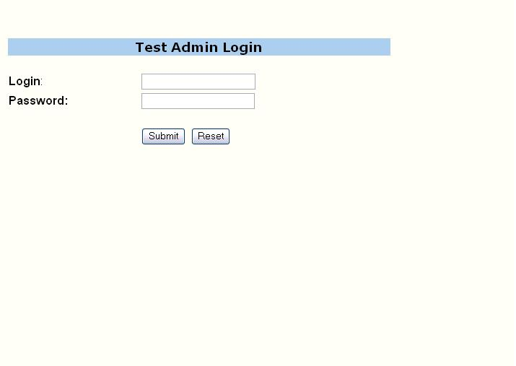

Admin Registration :-
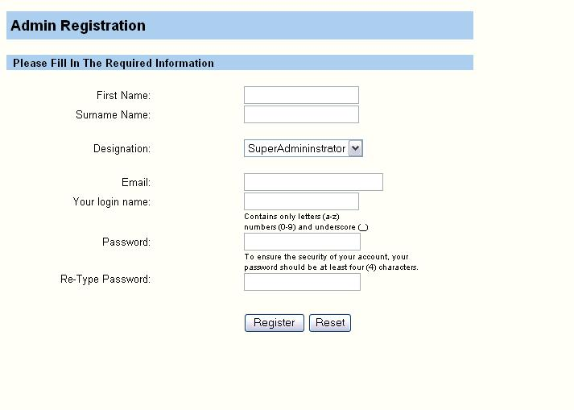

Add Question:-

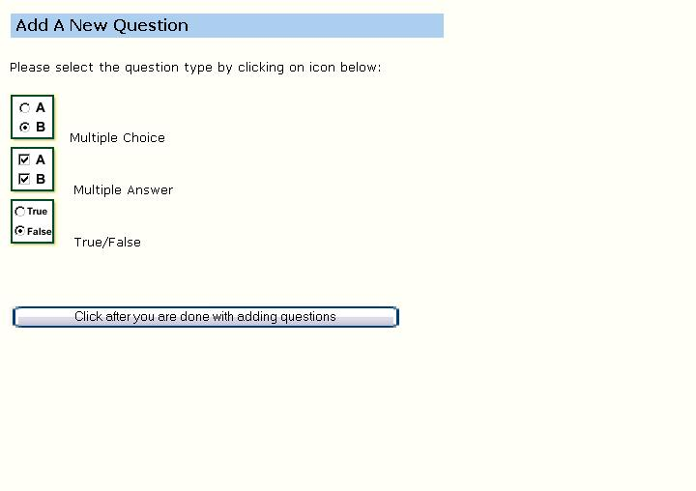

Create Category:-

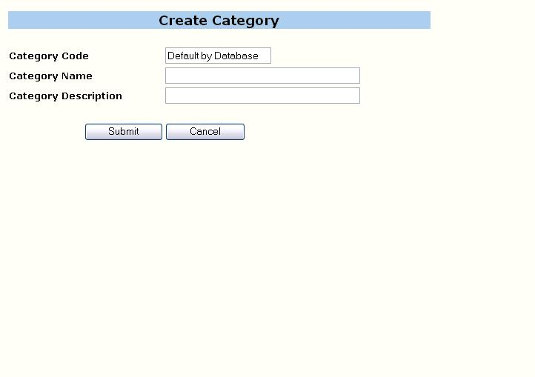

Create Test:-

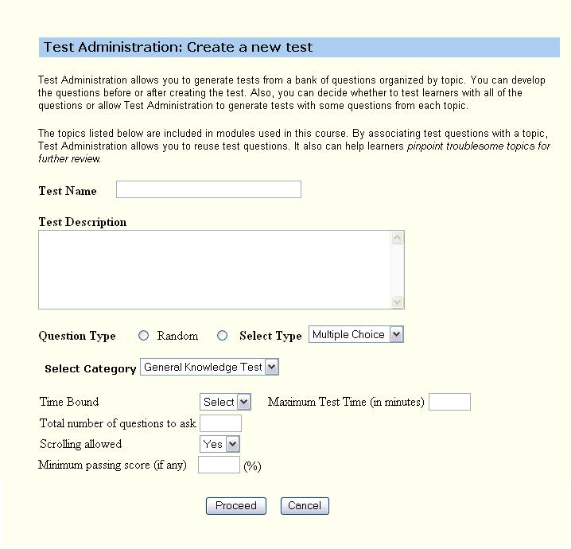

User Login:-

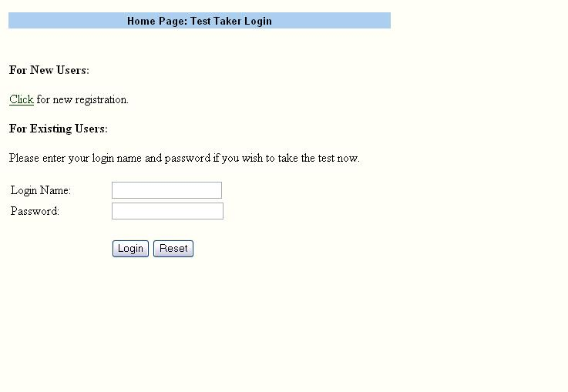

User Registration:-

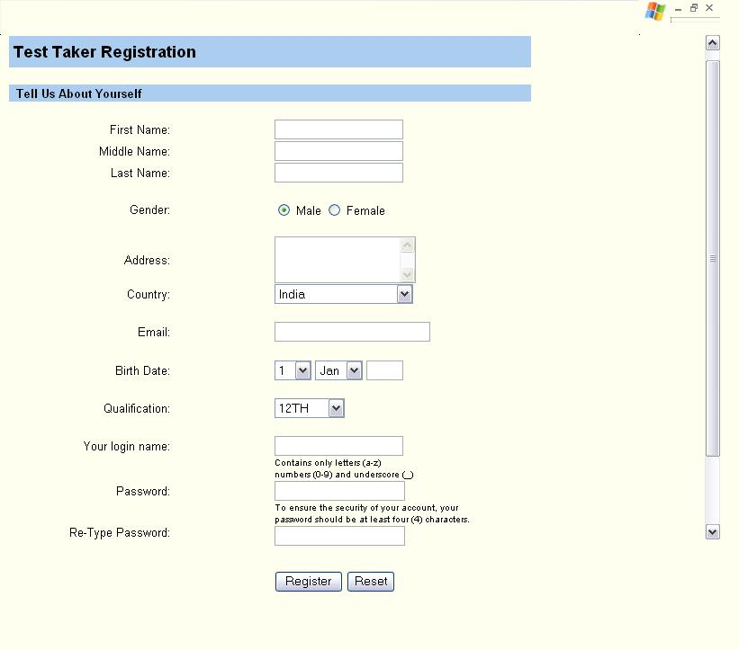
Report Format

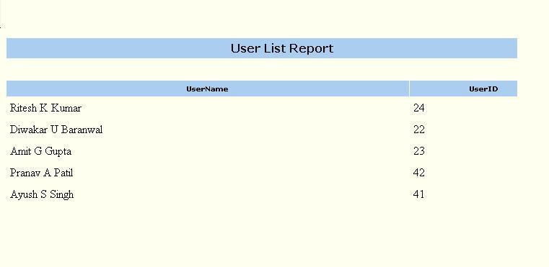

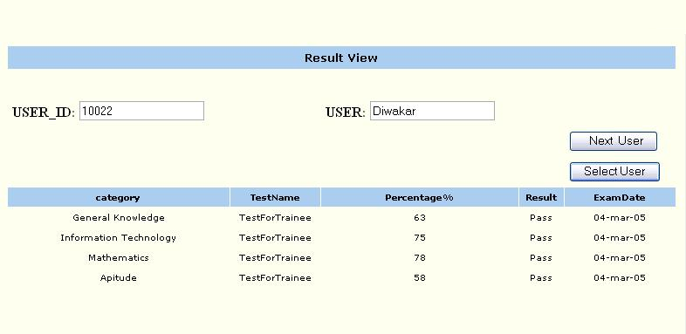

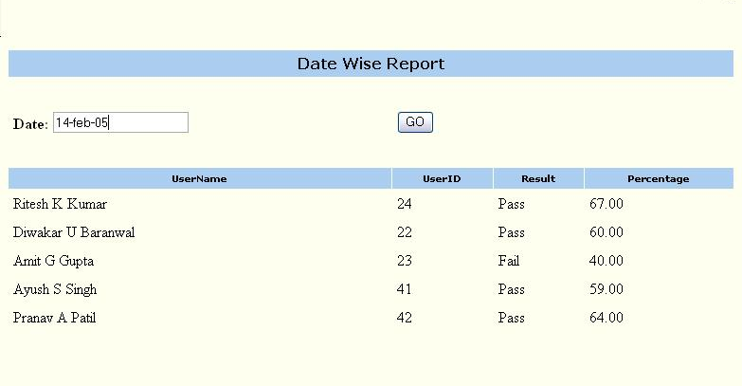
Drawbacks and Limitations

- The Look and feels of the project are static and are not according to the choice of the users. Users do not have any option to change it.

- The scope of the application is limited to Intranet in a small scale and cannot be deployed on Internet on a larger scale because of structural features which is designed purely for Intranet.

- There are security pot holes in the application. The application does not have a secure data transmission from clients to the server. In the name of security only the password fields in the User/Admin is encrypted.

- The application is based on the questions of purely text type and does not include any multimedia images, audio or video file.

- The log tracking implementation is not efficient. It does not give detail description of each event for error tracking.

- Users can only give a test of one category only once and if he wants to give it again he will have to come after a period of six months.

- The application does not support for subjective type of questions and essay type of answers
Further Enhancement

- Our Application is currently based on a single site of some company later it may be elaborated to encompass all the world wide located sites of the company.

- More focus on the security can be given in the later stage so that data is secure from eaves dropper and other misfeasors.

- Application now is just based on objective type of questions further in later stage it can be enhanced to support essay type answers based on some key words.

- The application can be also extended to include multimedia images, audio and video files.

- The Look and feel of the system can be set by the user and user should not be restricted to the look and feel what is provided by the system now.

- In later stage the system can be just made according to the post for which the test will be performed. Instead of displaying all the categories which a user appears now, users will just click on the post and everything will be guided to him accordingly.
Conclusion

At the time of beginning if this project, we had kept certain goals in mind. It is a great pleasure that the system is meeting most of the requirements that we hope to achieve. Many of the objectives and requirements of companies have been implemented.

This software can be used in any company as it fulfills the basic requirements of recruiting software. This software is user-friendly and can be easily learned.
Finally, it would be a pleasure to say that “Hard Work Leads to SUCCESS”. And our innovative crystal has done that.
Bibliography

Reference Books:

- Core Java Volume-II
By.Gary Cornell

- Developing java Servlet
By. GoodWill
- Oreilly Publication Java Servlet and JSP
By. Oreilly
- HEAD FIRST Servlet and JSP

- Oracle 8i - Complete Reference

- Software Engineering “A Practitioner’s Approach” Fifth Edition
By.ROGER PRESSMAN
Reference Sites:
- www.Google.com

- www.altavista.com

- www.javascript.com

